PCN NEWSLETTER  First Edition 2025 | 

*** Welcome to the first 2025 edition of The PCN Newsletter ***
Please contact your Surgery if you have not seen the Autumn 2024 edition.

(For this Newsletter in LARGER PRINT or an ALTERNATIVE LANGUAGE, please advise Reception).

Free monthly health and wellbeing ebulletin
Sign up to the monthly e-bulletin from Dudley Public Health and Wellbeing. Receive updates on local health information and advice on all life stages, from pregnancy and babies to healthy ageing. Find out about free local exercise opportunities, local mental health support and much more. To receive the bulletin go to https://public.govdelivery.com/accounts/UKDUDLEYMBC/signup/26294
Or scan this QR code


Plus, to follow the latest health and wellbeing news, sign up to the Healthy Dudley Facebook page https://www.facebook.com/HealthyDudley

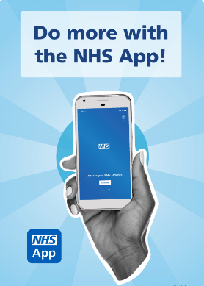
Take a look at the NHS App.
Take control of your health and access services when it suits you.
The NHS App provides easy 24/7 access to a growing range of health services and information. It doesn’t replace your existing services; you can still contact your GP surgery in the usual ways.

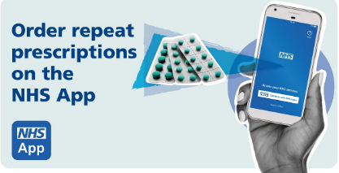
Request repeat prescriptions request prescriptions without having to contact your GP surgery and choose where you want to collect them.

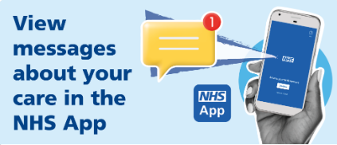
Contact your GP surgery request care or information from your GP surgery using an online form.

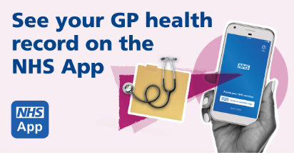
View your GP health record view your medical history, test results, allergies, medicines, and documents.

Manage appointments, check, and change appointments at your GP surgery and hospital, including hospital referrals and waiting list information.
Browse NHS health and medical information and find NHS services look for services near you and much more.

Visit Black Country ICB’s NHS App webpage where you will find lots of useful information and step by step guides - NHS App :: Black Country ICB

Don’t forget to visit your practice website too, where you can find information about how to contact your practice online.

Don’t have regular access to a smart phone, computer or internet? Black Country Connected :: Black Country ICS may be able to help you.

Coseley Family Roadshow October 2024 – Feedback

This was a very successful event organized by the Coseley, Gornal & Sedgley Connect Group plus The Coseley Primary Care Network and held at Jack Newell Court, Coseley.
A wide range of exhibitors attended on a variety of stalls offering free NHS Health checks along with representatives from a variety of Organisations was available to the public for three hours. Well attended and feedback from Exhibitors and Attendees suggested a very informative and relaxed atmosphere.

Amongst those attending were…

Dudley MBC “Living Well, Feeling Safe” focusing on health and independence. They offer a home assessment where a member of the team will identify any support issues such as home safety, security and improvements, health and well being along with social and leisure information. Telephone 01384 817743. - Keith.Marshal@dudley.gov.uk

Police – amongst other items, “Think whose after your money” - call the bogus hotline to report anyone you are not sure about. Telephone 01384 812045.

“Merrie Maggie” – Certified Laughter Yoga Teacher – Telephone 07565 218567 – stressed the importance of laughter in making people feel good. She offers sessions to support groups with long term medical conditions including Retirement Homes and Groups.

The Beacon Centre – Telephone 01902 880111 – free advice, guidance and support from Sight Loss Advisors.

Sedgley Evening Townswomen’s Guilds – 07794 618943 – a wide variety of events including singing, craft, walking, guest speakers, outings, plus support for End Violence Against Women.

Laura Martin - Dudley Stroke Association - laura@dudleystrokeassociation.org.uk

Jo Bedworth - Family Hub Manager - Jo.Bedworth@dudley.gov.uk

Najma Saleem - Community Health, Wellbeing and Inclusion Coordinator -Najma.Saleem@dudleycabx.org

